Lab Sheet 8
Question 01
1.Markov Decision Process . ipynb
Policy Evaluation Result (Complete code ) :-
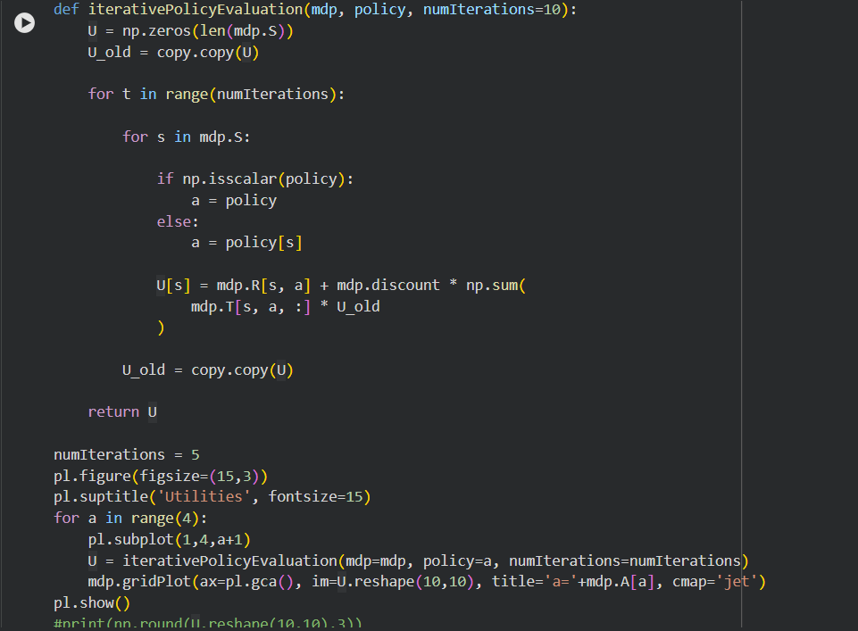

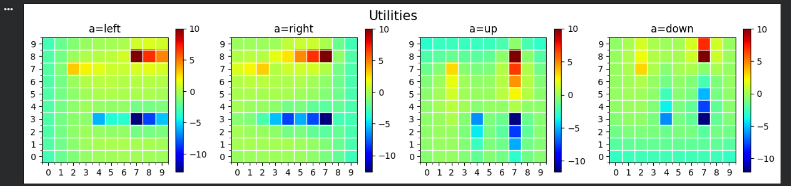
Value Iteration Result (Complete Code) :-
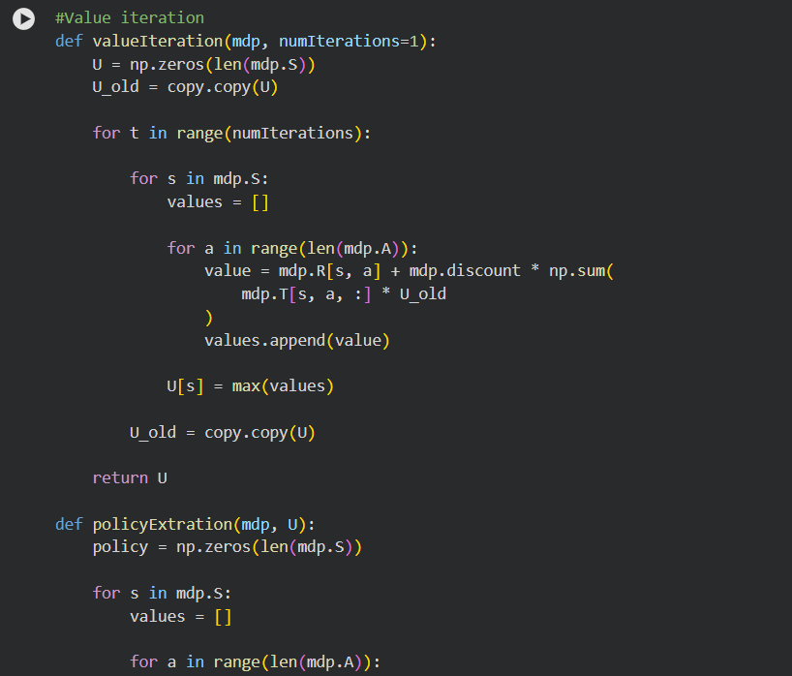

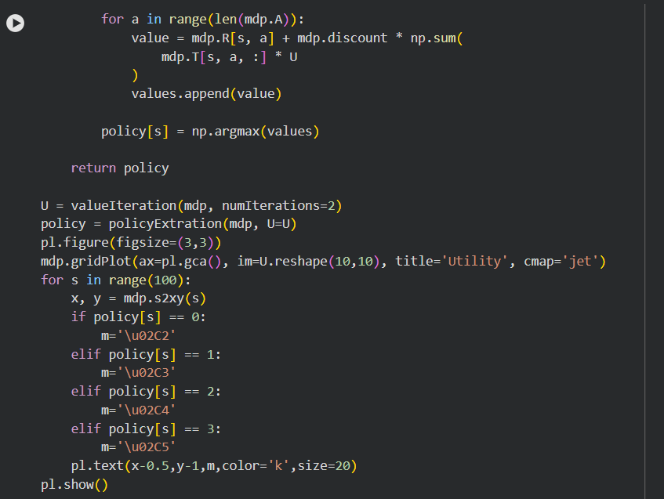
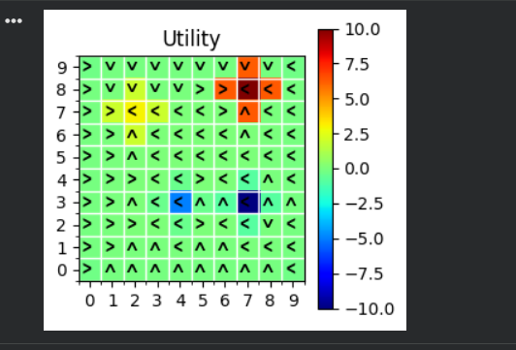

Policy Iteration Result (Complete Code): -
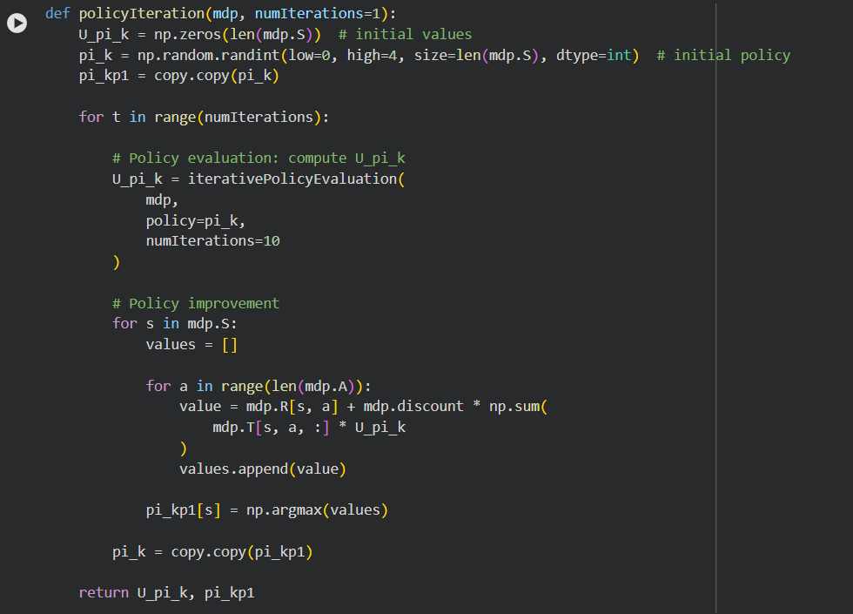
2.GridWord.ipynb
Random Agent Result (Complete Code) :
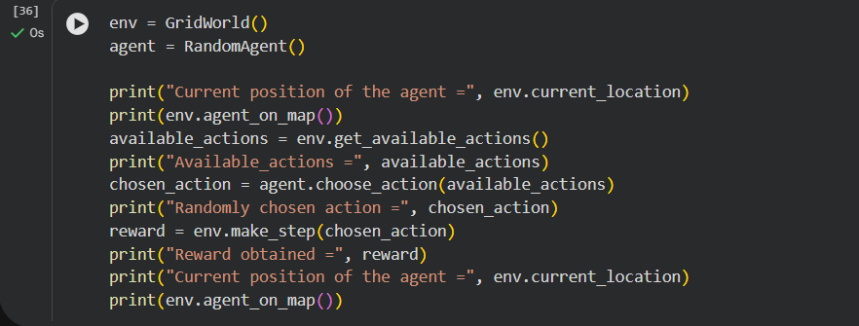

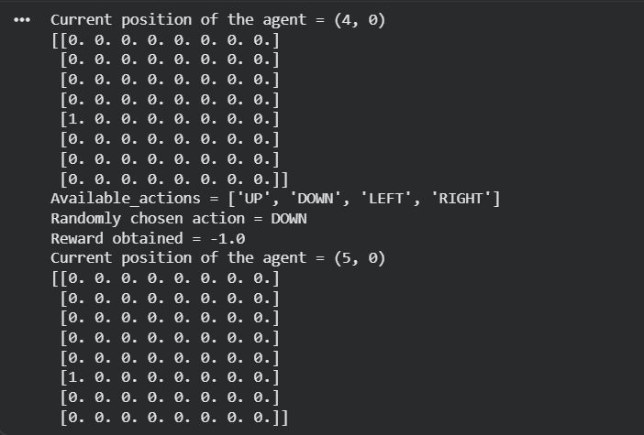

Q-Agent learning Curve
8 x 8 , execution time :-
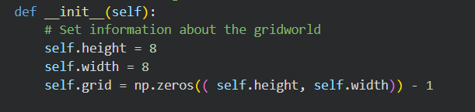

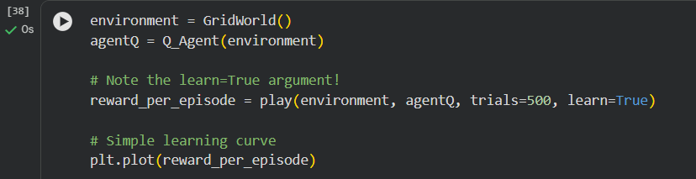

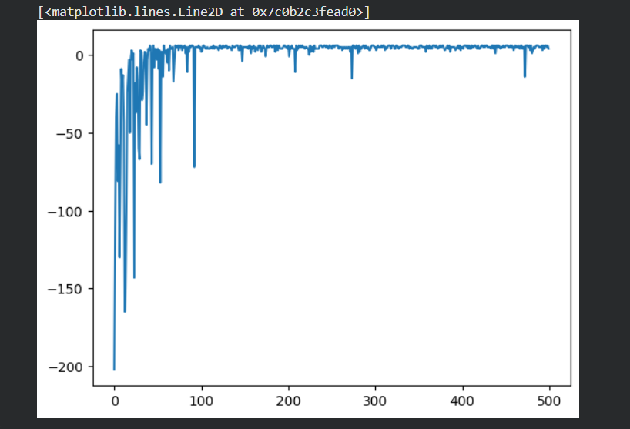

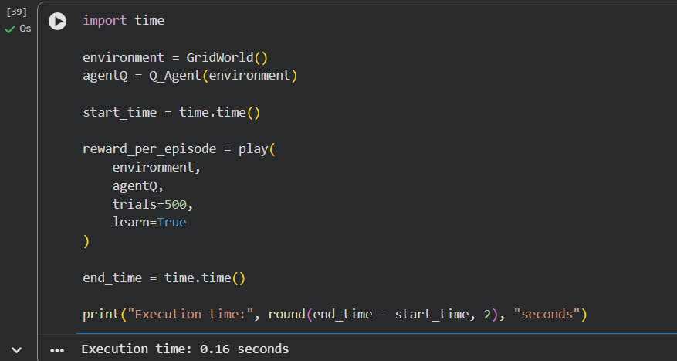

20 x 20 , execution time :-
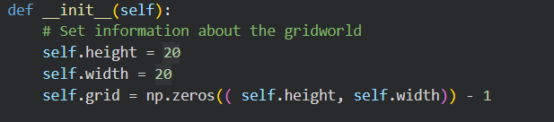

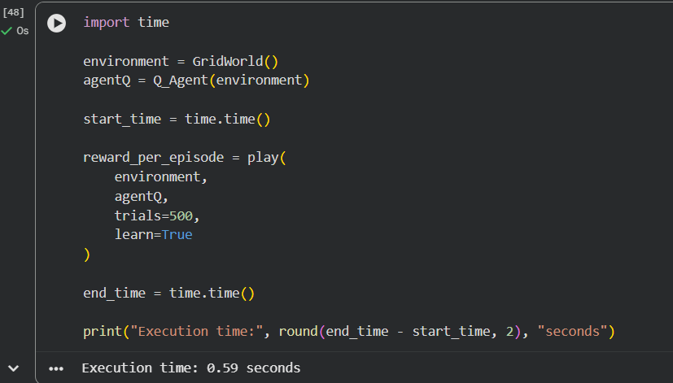
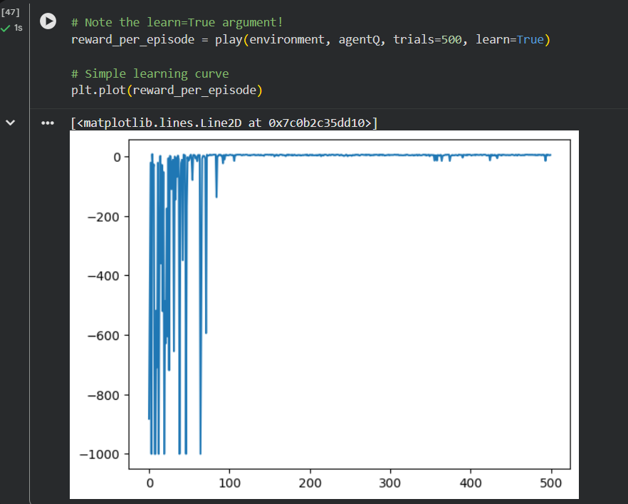
Question 02
Part 1 - Compare execution time and convergence
A. Model-Based approach - Policy Iteration
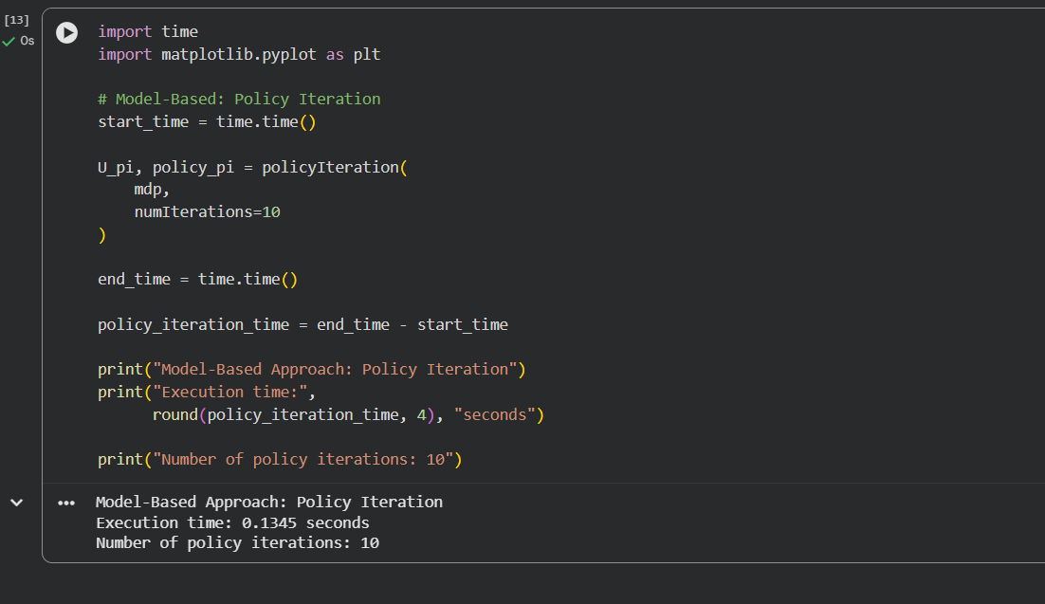
Comparison Table:-
Approach | Algorithm | Environment | Iterations | Execution Time
Model-Based | Policy Iteration | MDP | 10 iterations | 0.1345 s
Model-Free | Q-Learning | GridWorld | 500 episodes | 0.16 s

2. Differences between model-based and model-free
Feature | Model-Based | Model-Free
Environment model | Required | Not required
Transition probabilities | Uses them | Does not need them
Reward model | Uses it | Learns from observed rewards
Learning method | Policy evaluation + improvement | Q-value updates
Interaction required | Less dependent on trial-and-error | Requires experience

3. Policy Iteration Screenshot

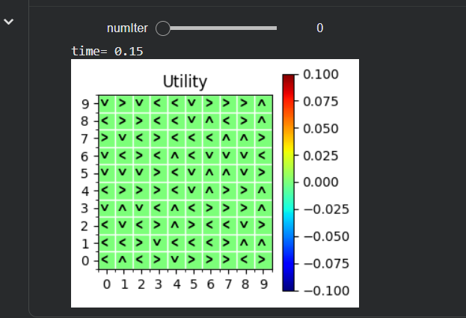
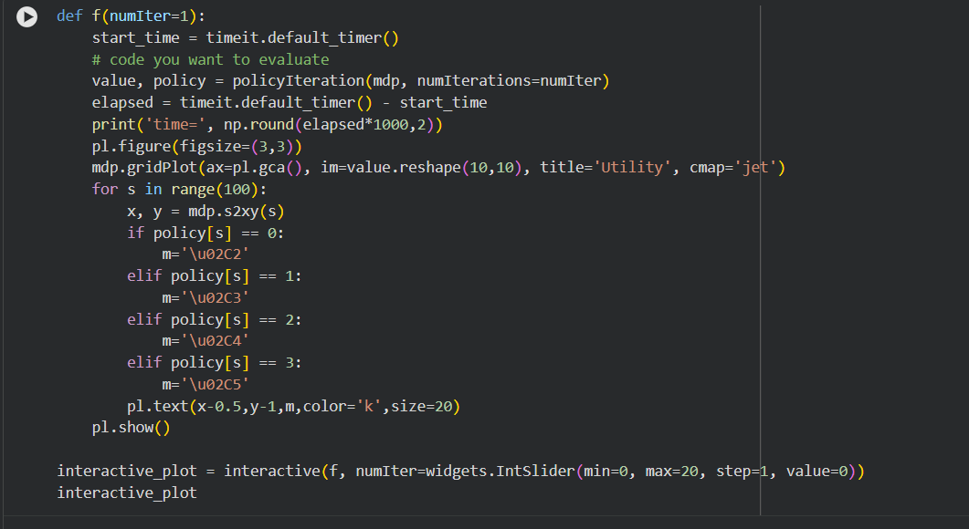

Q-Learning Screenshot
